1. What is a friend function / method ?

**A. It is permitted full access to private and protected members of a class**

b. It creaates an object by initializing it with an object of the same class, which has been created previously

c. it is a special function / method in a class that is called when a new object of the class is created

e. it is used to expand the code in the body of the function / method in place of a call to the function / method

2.

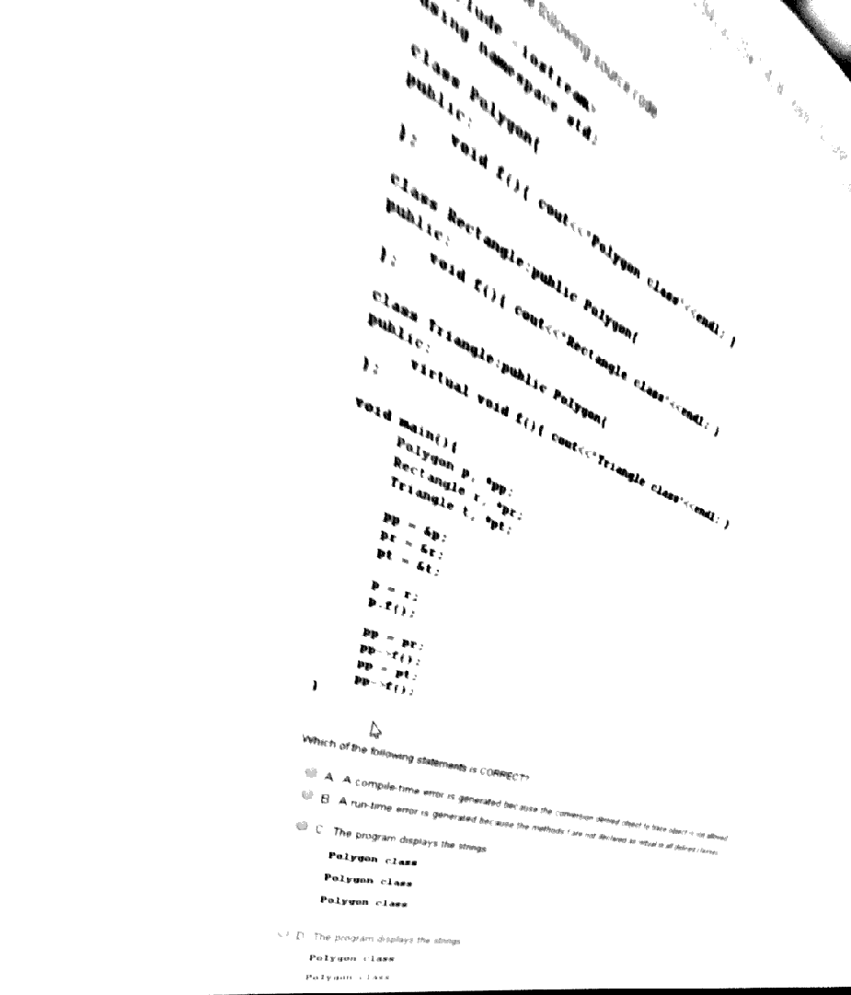

3. Choose all correct statements about the char type in java:

**a) Default value is \u0000**

**b) has 2 bytes**

c) default value is true

d) default value is null

e) has 1 byte

4.It considers the following OpenSSL function call RSA_private_encrypt(sizeof(finalDigest), buf, e_data, apriv, RSA_PKCS1_PADDING). The private key has a length of 1024 bits. Which of the following statements is CORRECT?

A. RSA_PKCS1_PADDING has the same length with the private key;

B. sizeof(finalDigest) represents the digest of the message;

C. A compile-time error is generated because the function has other header;

**D. RSA_PKCS1_PADDING is a parameter specifying the padding type;**

E. RSA_PKCS1_PADDING is a parameter specifying the padding length;

5.Which one from the next Java statements it CORRECT:

A. abstract classes can be instantiated in objects;

**B. abstract classes can contain non-abstract methods and instance variables;**

C. All these statements are NOT correct in Java

D. interfaces can NOT be used as reference type;

E. interfaces can contain instance variables

6. Which methods will every class contain ?

**a) constructor + destructor**

b) getter+setter

c) -

d) -

7. Given

class Base

{ static { System.out.print("b1 ");} // static init block – executed once { System.out.print("b2 ");} // instance init block – executed for every object created public Base(){ System.out.print("b3 "); } } class Subclass extends Base{ public Subclass(){ System.out.print("s1 "); } } public class Main { public static void main(String[] args) { System.out.print("main "); new Base(); new Subclass(); } }

what is the result ?

A. main b1 s1 b2 b3

B. main b2 b3 s1 b1 b2 b3

C. main b1 b3 s1 b2 b3

D. main b1 b2 b3 s1 b2 b3

**E. main b1 b2 b3 b2 b3 s1**

F. it can't be determined

G. b1 main b2 b3 s1 b2 b3

8. What does a destructor return ?

A destructor will have exact same name as the class prefixed with a tilde (~) and **it can neither return a value nor can it take any parameters**. Destructor can be very useful for releasing resources before coming out of the program like closing files, releasing memories etc.

a) -

b) -

c) -

d) -

e) -

9. It considers the following source code:

#include <stdio.h>

#define NMAX 100

#define then

#define BEGIN { #define END } #define INTEGER int

void main() BEGIN INTEGER S = 0; INTEGER vector[NMAX]; for(INTEGER i=0; i<NMAX; i++) vector[i]=i+1; for(INTEGER i=0; i<NMAX; i++) S+=vector[i]; printf("S= %d",S); END At run-time, the result of the above application is:

A. 50;

B. 0;

**C. 5050;**

D. The application generates a run-time error;

E. The source code cannot be compiled;

---------------------------------------------------------------------------------------------------------------------------

De aici incep intrebarile care sunt asemanatoare dar nu garantez ca sunt identice cu cele de la examen .

10 .

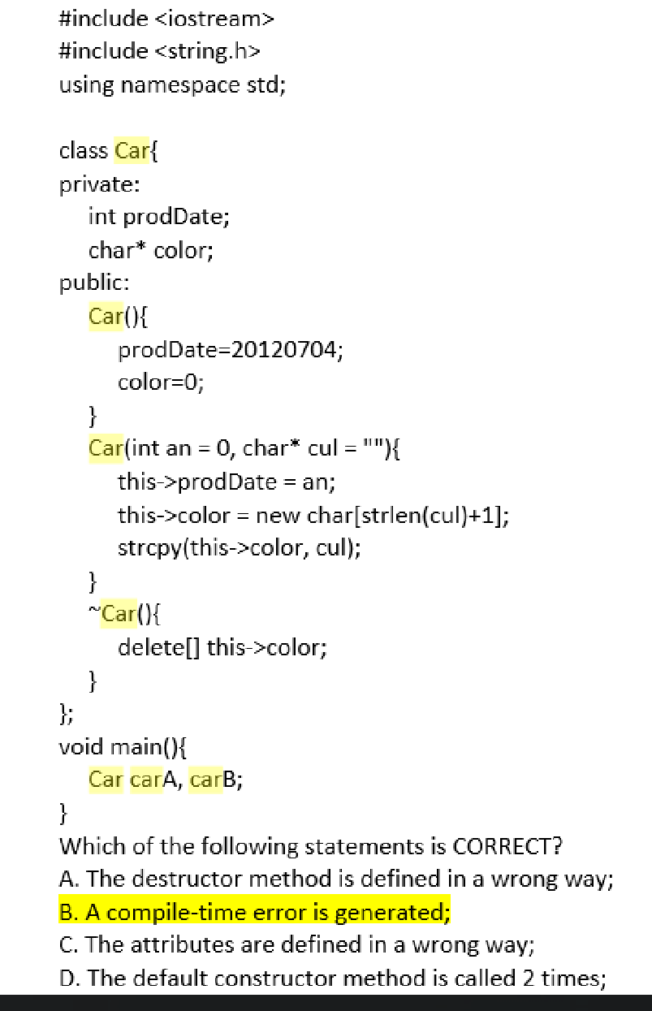

11. Aici era modificat prodDate = 20160104

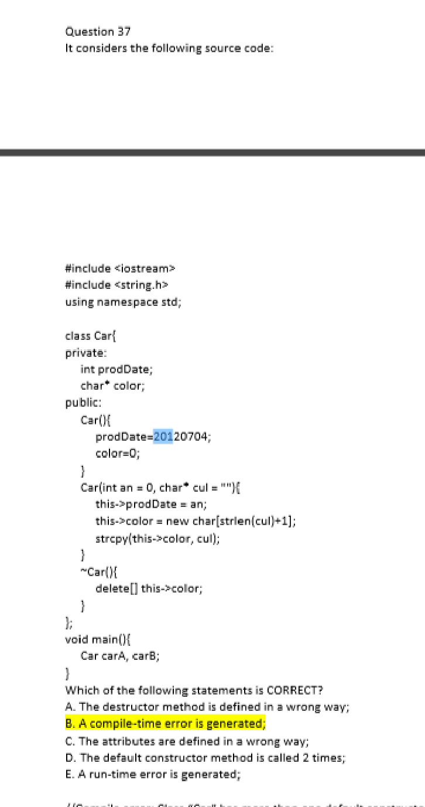

12.

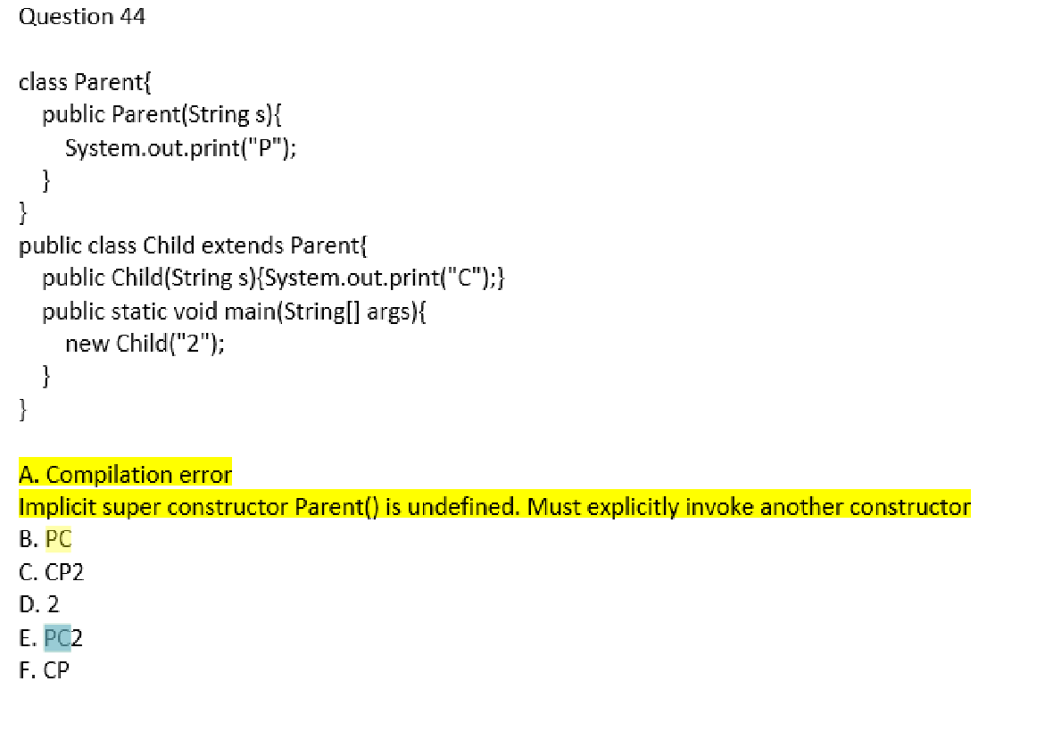

13.

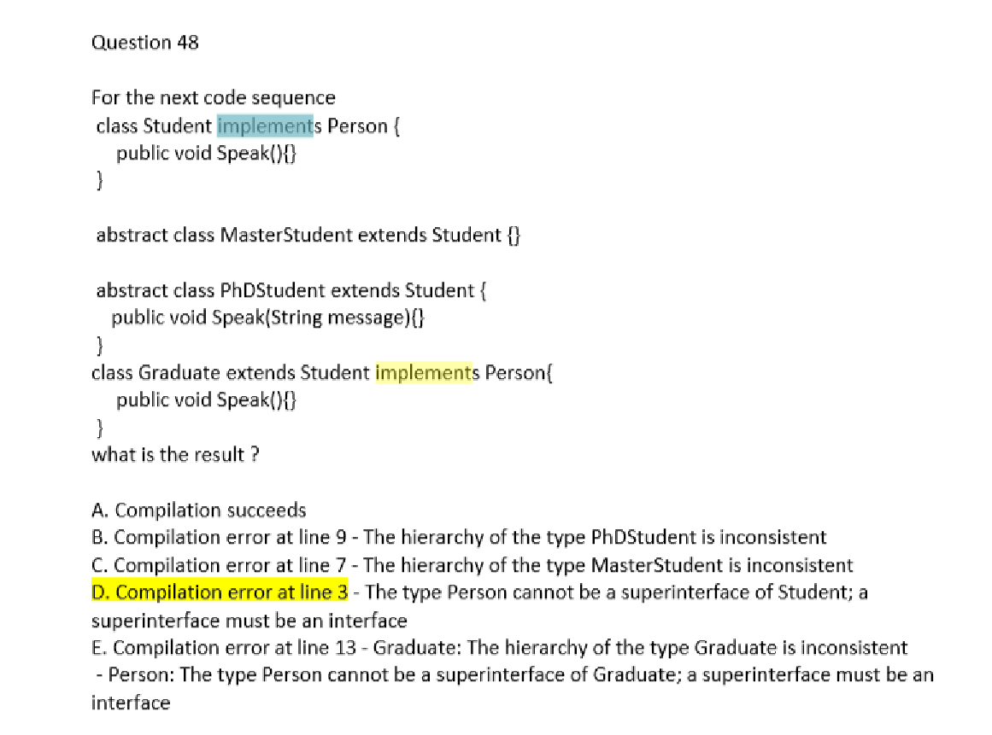

14.

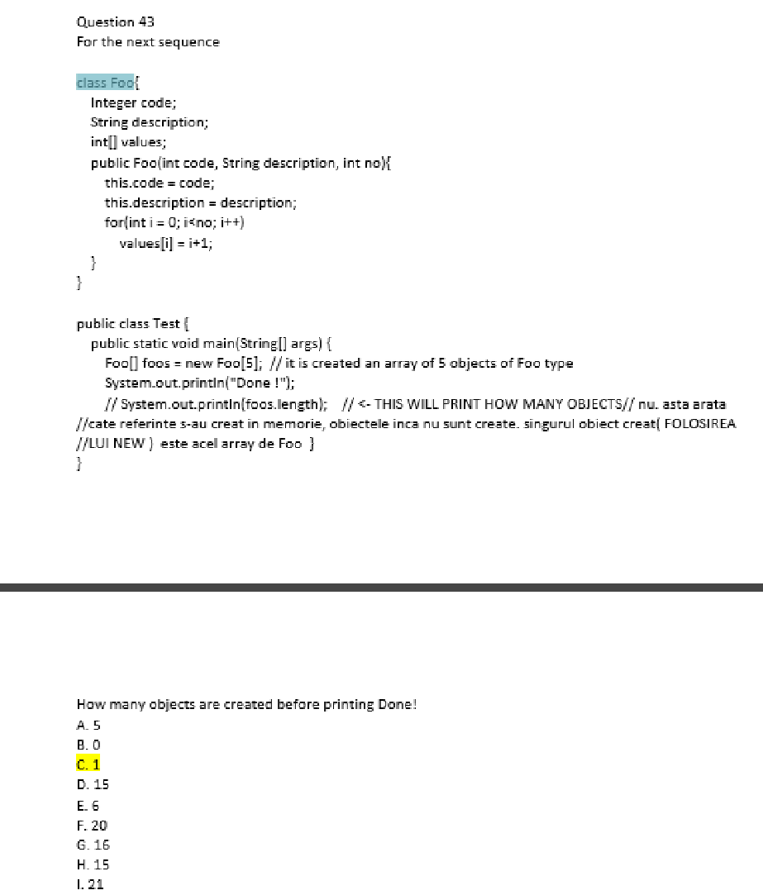

15.

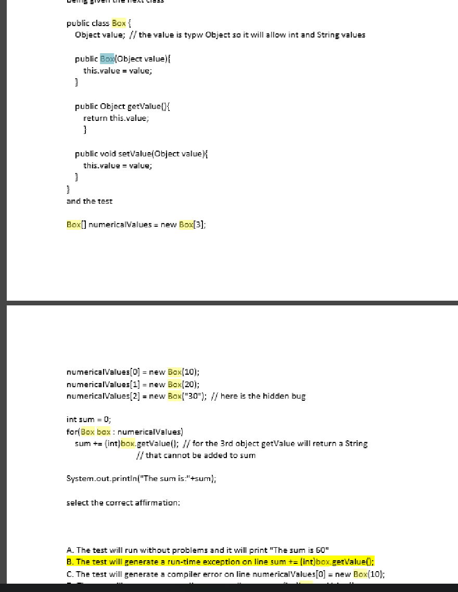

16.